**EXCEL DATA COMPARATOR**

Excel Data Comparator is used to compare the data between the “Source” sheet and “Target” sheet. Guidelines are given in the “Compare” sheet where you can find the functions as well. Kindly go through the “Instructions” given in the “Compare” sheet.

**FUNCTIONS:**

1. Exact
2. Compare
3. Count
4. Missing Source
5. Missing Target

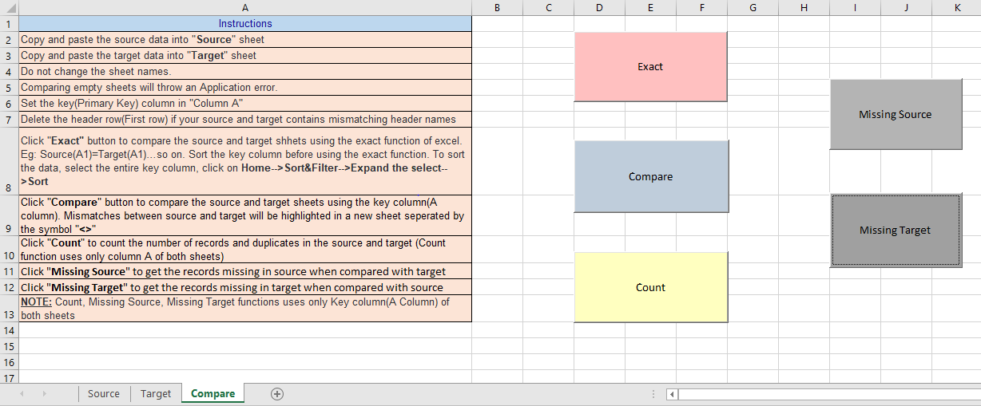

**EXACT:**

“Exact” function compares the data between Source and Target sheets using the Exact formula in Excel. In other words, it compares the cell A1 of Source and A1 of Target. i.e It checks whether A1Source=A1Target, A2Source=A2Target……so on, till the last row of the last column. If there is a mismatch, it will be highlighted in the respective cell in a new sheet and as well as it gives the number of mismatches found. An example is given below

Source: Target:

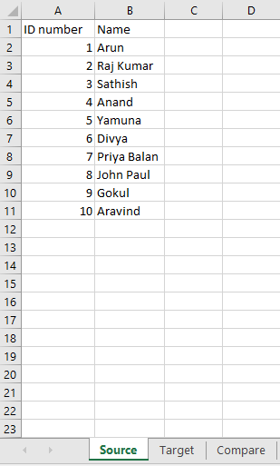 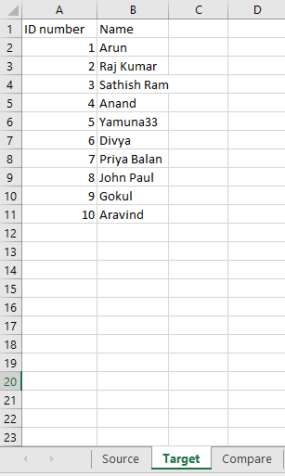

Result:

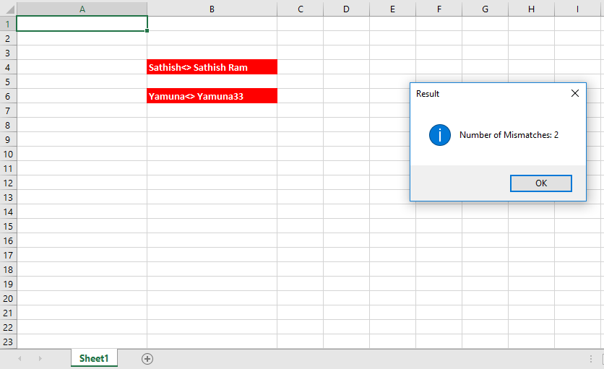

NOTE:

Data between the Source and Target should be aligned using the Sort option in Excel if the data is not aligned. Please find the steps to sort the data in the Instructions in “Compare” sheet.

**COMPARE:**

“Compare” function compares the data between Source and Target sheets using the Primary key column (A Column of both sheets). It takes the value of A1Source and checks A column of Target sheet, once the value is found, it then checks the respective row data between the Source and Target. If there is a mismatch, it will be highlighted in the respective cell in a new sheet along with the Primary key and as well as it gives the number of mismatches found. An example is given below

Source: Target:

 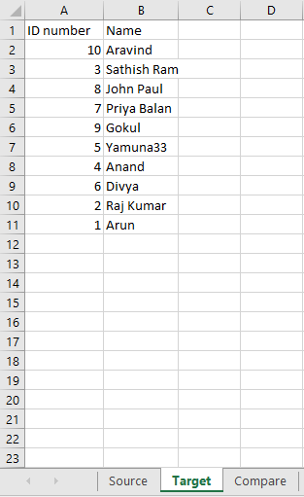

Result:

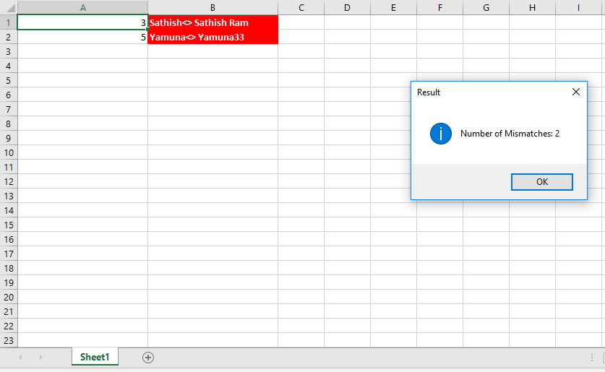

NOTE:

If Primary Key column (A column) contains duplicate values, then align the data using the Sort option and use the “Exact” function.

**COUNT:**

“Count” function counts the number of records and duplicates in the Primary key column (A Column) of the Source and Target sheets. This function uses only the Primary Key column (A Column) of both sheets and disregards all the other columns. An example is given below

Source: Target:

 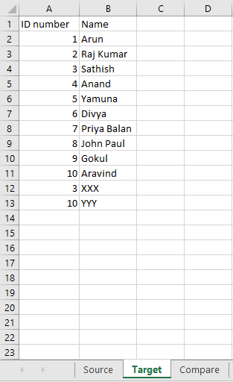

Result:

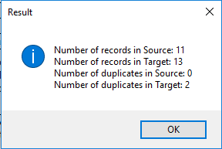

NOTE:

“Count” function counts from the first row till the last row of A Column of both sheets. If the data contains header (First row), then Number of records = Total Count -1

**MISSING SOURCE:**

“Missing Source” function returns the missing records in Source which are present in target using the Primary Key Column (A Column) of both sheets. It also gives the count of missing records in Source. Missing records will be captured in a new sheet. An example is given below

Source: Target:

 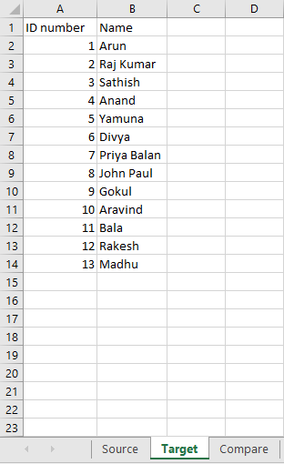

Result:

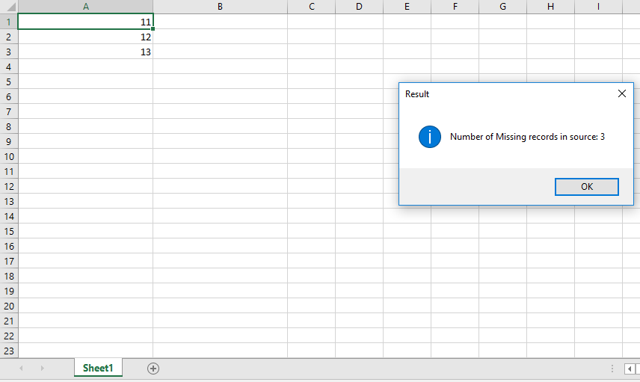

NOTE:

“Missing Source” function uses only Primary Key Column (A Column) of both sheets.

**MISSING TARGET:**

“Missing Target” function returns the missing records in Target which are present in Source using the Primary Key Column (A Column) of both sheets. It also gives the count of missing records in Target. Missing records will be captured in a new sheet. An example is given below

Source: Target:

 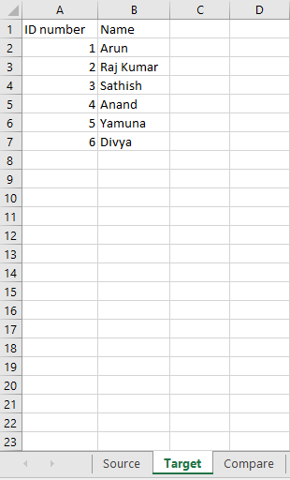

Result:

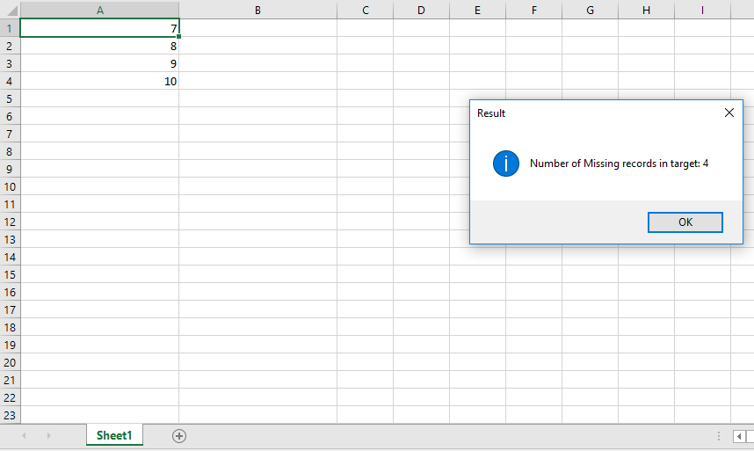

NOTE:

“Missing Target” function uses only Primary Key Column (A Column) of both sheets.